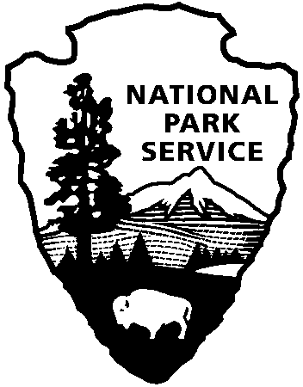
National Park Service
U.S. Department of the Interior
Bent’s Old Fort National Historic Site
35110 Highway 194 East
La Junta, CO 81050
(719) 383-5010
www.nps.gov/beol

Bent’s Old Fort National Historic Site

Family Self-Guided Activity Book
  - Supplement to Self-Guided Tour Book
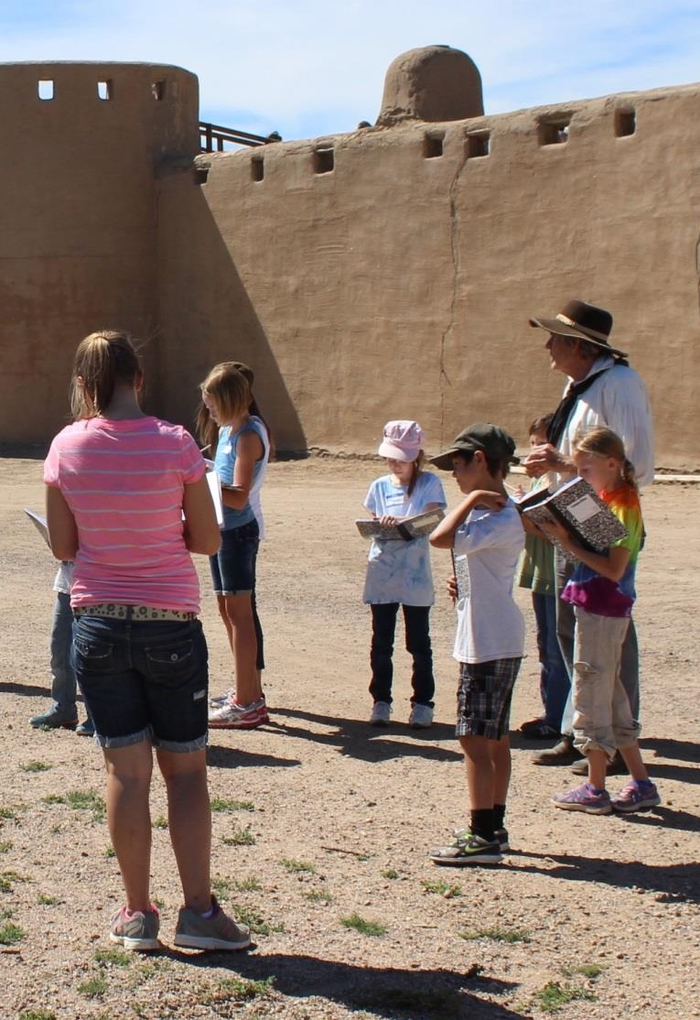

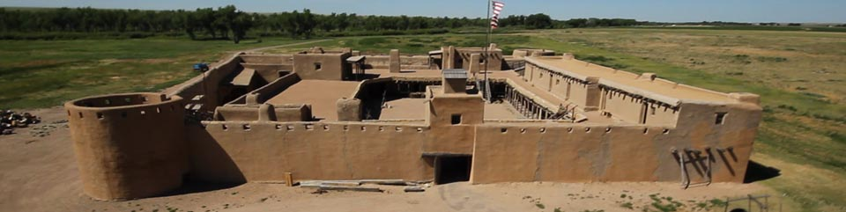
To Parent/Guardian: This guide’s goal is to enhance the experience of your family by providing you with resources to make your visit to Bent’s Fort more interactive. It complements the regular self-guided tour book. Use it at your own discretion.

Directions:
- Discuss the rules for 2 minutes with your family. Consider asking your children what rules they think they should follow before going over the rules listed on this page.
- Read the introduction page (next page).
- Start in the Room 1 - The Council Room.
- Talk to all living historians (staff in period clothing from 1846) and complete page 5 for each.
Goal: By the end of the visit, you will be able to explain, “What makes Bent’s Fort special.”

Rules:

Be respectful to yourself
- Stay with your family/friends
- Do not run (you might trip and hurt yourself)
- Pay attention to your family and surroundings
- Have fun in a safe manner

Be respectful towards others
- Do not hurt others
- Do not throw anything
- Listen to what others say
- “Attack ideas, not the person they're attached to”

Be respectful of the fort
- Leave the cats, peacocks and livestock to themselves
- Do not vandalize
- Do not open cabinets or chains
- Do not go past chained-off areas
- Touch, but do not take away, items from their areas

Your Background Story:
You are archaeologists from the 21st century. Your friend invented a time machine and you are testing it out by traveling to Bent’s Fort to the year 1846. You want to learn about the fort and why is it important to our history. In order to learn about Bent’s Fort, you need a cover story so that you can interact with the people of this time. Use the story that you are trappers from Missouri. Designate a Head Trapper to introduce your group to living historians.

Introduction Activity
The year is 1846. Your great, great grandfather was alive. Imagine yourself out on the Santa Fe Trail, walking for 60 days. Bent’s Fort is very isolated; the closest town is 600 miles away. Bent’s Fort is a trading post where many people replenish their goods. The main trade with the Native Americans is Buffalo Robes. Some uses of the robes were rugs, bedding and lap warmers. A trader at Bent’s Fort would trade items such as woolen blankets and beads to Native Americans in exchange for Buffalo Robes. The fort is made of adobe-good for defense because cannon balls cannot go through it-but it needs continual maintenance because the adobe becomes mud when it rains.

Activity:
Using the context of the words from the paragraph above, match the following words to their definitions.

Trade
Trading Post
Isolation
Adobe
Buffalo Robes
The state of being in a place or situation that is separate from others.
An exchange (something) for something else, typically as a commercial transaction.
A small settlement established for trading, typically in a remote place
A rug, cloak, or blanket made from the dressed hide of a North American bison.
A kind of clay used as a building material, typically in the form of sun-dried bricks.

This land used to have over one million buffalo. Native American men hunt the buffalo and the women scrap off the meat from the hide. They do so by rubbing buffalo brains on the underside of the hide. Brain tanning a buffalo hide take approximately 10 days. Buffalo robes were traded at Bent’s Fort. Over 13000 pounds of buffalo robes were taken back east to be traded this year (1846). Their primary usage is as lap blankets for riding in wagons.

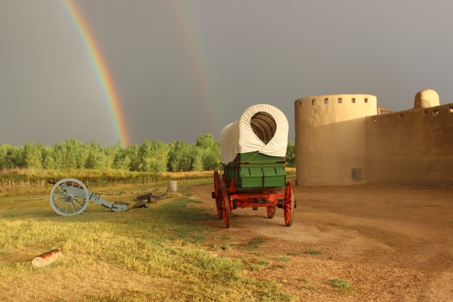

Discuss
- Does anyone know other uses of the Buffalo? Answer- (Food, tools, blankets, teepees)
- What impact does the buffalo trade have on the ecosystem?
- What river is near Bent’s Fort? Answer- Arkansas River
- Have you previously visited Bent’s Old Fort?
- Have you visited other places on the Santa Fe Trail?
- Who owns Bent’s Old Fort? (Hint: This is a trick question because it has two answers.)
Answer: The owners of Bent’s Old Fort in 1833-1849 were William Bent, Charles Bent, and Ceran St Vrain. The National Park Service manages Bent’s Old Fort National Historic Site, but the public (including your family/friends) owns it.

Bonus:
As you tour the fort, can you find renewable sources and non-renewable sources of energy? We will define a renewable source of energy as a source of energy that can be replaced within a human lifetime.

Living Historian Activity (When you encounter Bent’s Fort staff in period clothing)
You may assign questions to individual family members, or have the “head trapper” of your group read off the questions. The goal of these questions is to make this experience more interactive.
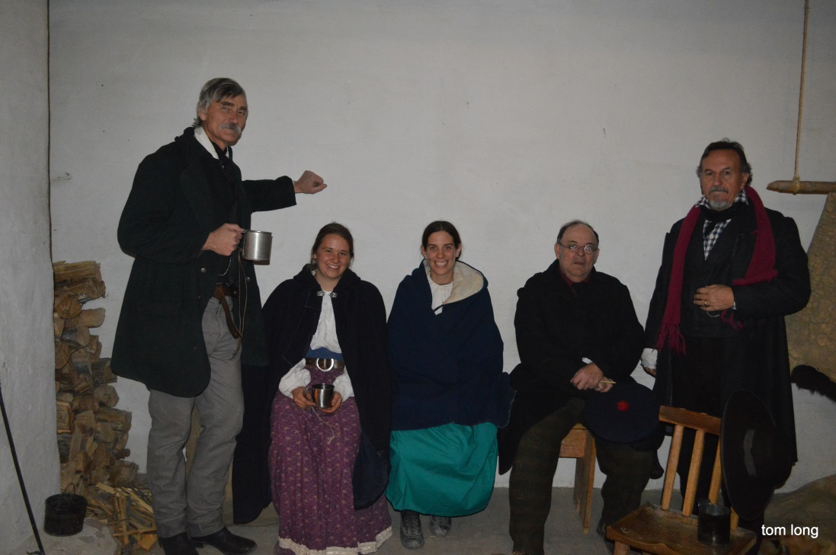
- Introduce your group- The Head Trapper introduces group to the living historian (the person in 1840s clothes).
- Respond to any questions the living historian asks.
- Find out if the person had choices in his/her job.
  - Ask these questions.
    - What kind of work do you do?
    - What brought you here?
    - How does this country affect your work?
    - How did you come to do the work you are doing?
    - Can you show us what you do for work?

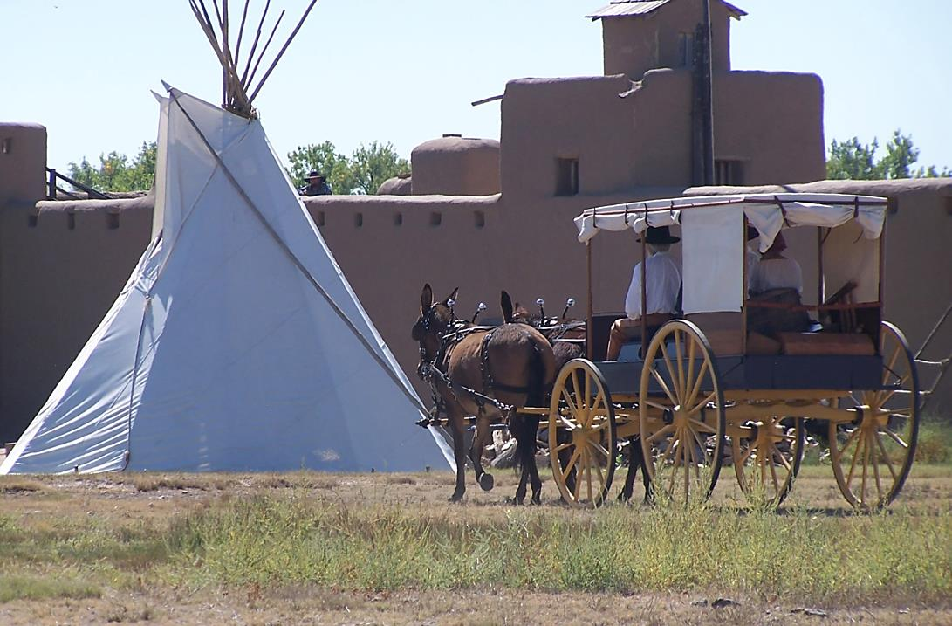

Maps of First Floor
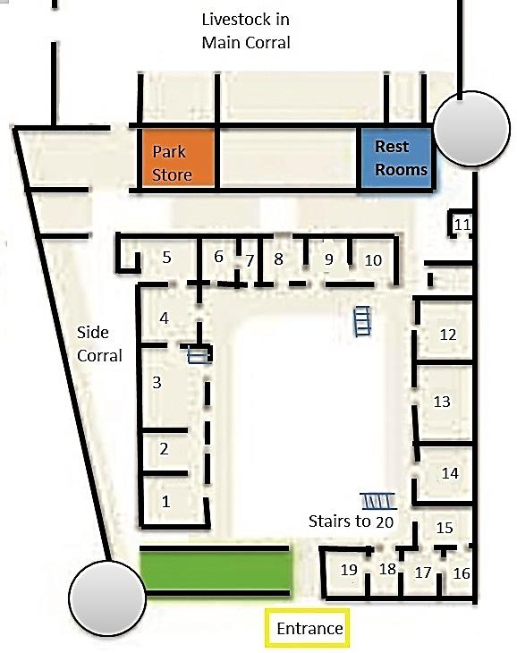
Start in Room 1 (Council Room)
Map of Second Floor
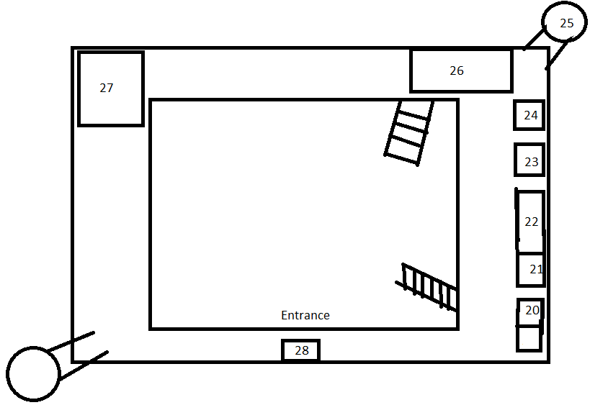
Start in Room 20 (Doctor’s Office)

(Room 1) Council Room
The purpose of the Council room is for negotiations about trade goods. After being invited into this room, friendly tribes of Indians, such as Cheyenne and Arapahoe, were presented with coffee and gifts before talking about the trade items. When the trade is finished and successful, a pipe was passed around to the men. The women were allowed in the council room but would not speak or actively participate in the discussions.
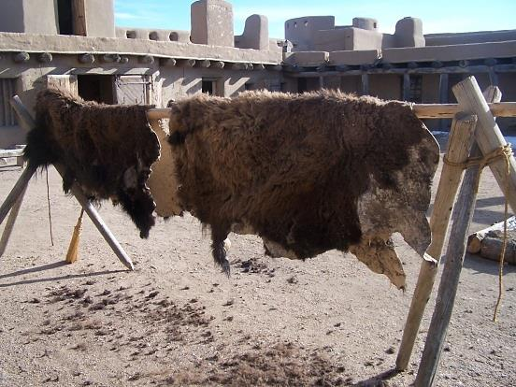
Buffalo Robes
Touch a buffalo robe. How does it feel?

Trade Activity:
- Divide your family into two groups in order to carry out a trade.
- One group is a friendly Cheyenne Indian tribe that has a buffalo robe they want to trade for money. Your group wants to be paid at least 15 cents for the robe. No one in your group can speak English (the language of the white traders).
- One group represents white traders. Your group wishes to pay no more than 5 cents for the robe. No one in your group speaks or understands Cheyenne.
- Each group can quietly discuss amongst its own members what they want to do, but they cannot speak to the other group. Give 30 seconds to whisper in their groups. Then, announce that it is time for the groups to trade. Carry out the trade!
Lieutenant Abert's Painting of the Council Room

Discussion:
- Could you communicate and reach an agreement?
- Did the groups designate a representative?
- How will you communicate if you cannot speak the other language?
- Were you able to solve this conflict (problem)?
- In the 1840s, the Indians would trade the buffalo robes for about the value of one dollar at the time. Would the Indians want to be paid in silver or in items?

(Room 2) Main Trade Room- Do NOT go behind the counter!
People from all walks of life stopped at Bent’s Fort. They might have gone into this trade room. Touch the buffalo robe located on the counter. This is what the Indians traded for items you see in this room.

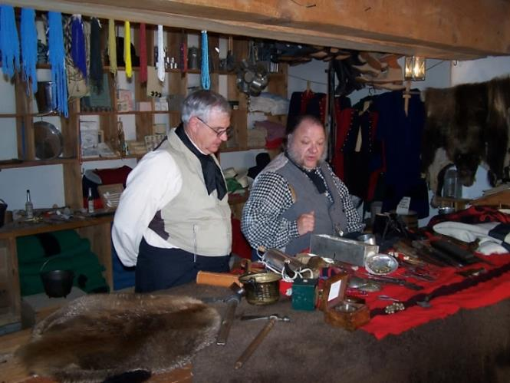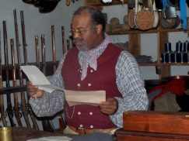

Have your family/friends point to the items listed below:

- Wearable decoration
- Weapons or parts for weapons
- Edible items (food)
- Items used for cooking
- Blankets

Which of the items mentioned might the following people want to trade for and why?

- Native Americans
- Fur Trappers
- Traders
- Travelers on the Santa Fe Trail
- Sick/recovering soldiers of the Army of the West

  - Example of Trade Value in the Early 19th Century
Note: Trade values were different depending on location, year and time of year.

1 robe………………………….………….about $3
60 loads of powder and shot……….1 robe
Trade gun…………………………….6- 10 robes
2 gallons shelled corn………………….1 robe
3 to 4 pounds sugar…………………….1 robe
2 pounds coffee………..………………..1 robe
Pint of alcohol…………………………….1 robe
1 hank (group) of beads………………1 robe
1 yard cloth or flannel……………………1 robe
1 Fathom (6 feet) large beads………..1 robe
Rifle……………………………………………12 robes
Fusil (Flintlock musket) ……………….8 robes
Abalone shell………………………..4 to 8 robes
1 gallon kettle……………………………….1 robe
3 knives…………………………………………1 robe
Blanket………………………………….3 to 4 robes

Discuss:
Many of these items were for Native American wives. The Indian wife owned the teepee, made the clothing and cooked.
- What would you do if you wanted more items then you had robes to trade? (This might lead to a discussion about Indians hunting more buffalo to trade for more items. You might discuss priorities and how to determine them.)
- Did traders have to know fractions? Answer: yes. You can use the example of trading one buffalo robe for two knives and one pound of sugar.
- What did the Indians cook with before the “iron kettles,” also known as pots, were available?
Answer: Buffalo stomachs. In addition, large intestines could be used to hold foods.
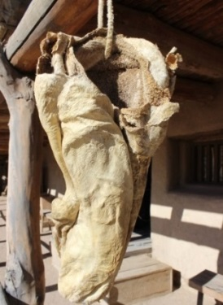 Buffalo stomach hanging in the plaza

(Room 3) Dining Hall
The dining room at Bent’s Fort was one of the ways status was demonstrated. Most workers at Bent’s Fort were not allowed in this room at all! They cooked and ate their food in their own quarters or outside. Only the owners and their invited guests sat at what was called “First Table”. It was only after First Table had finished eating that the other tables could be occupied by other residents or visitors at the fort, for example traders, sick or recovering soldiers and merchants.

Discuss
- What items in this room represent that this room is set up very fancy for being in an isolated fort?
- How do you or your family set up your dining table at home?
- Have you ever been in a situation that you felt marginalized (left out)? If you feel comfortable doing so, share it with your group.
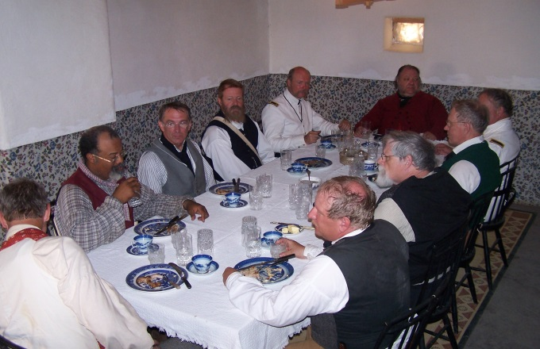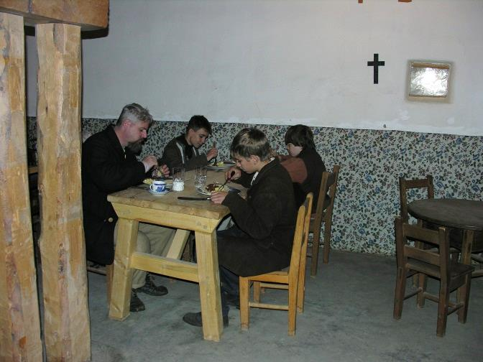

Men eating at First Table

Men eating at Second Table

(Room 4) Cooks Quarters
The single women who worked for the Bent, St Vrain Company, slept in the Cooks Quarters.

Discuss
- Why do you think the cooks lived in this location of the fort?
- Can you find clues to what the cooks might do when they are not cooking?
- Do you see any beds in this room? Why do you think this room is represented that way?
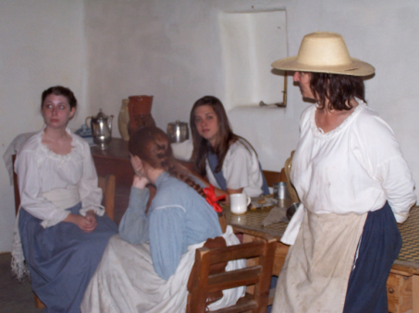 Women in Cook’s Quarters

(Room 5) Kitchen
The kitchen was used for cooking food for the people who would eat in the dining room. Since every living quarter would have a fireplace, other people would cook their meals in their own quarters or in the plaza.
- What source for heat energy did the cook use for baking and cooking?
- Point to items used for cooking.
- Do you use any similar items when you or your parents cook?
- Can you find the dried chilies? (reddish fruit hanging to dry) There were little or no citrus fruits, such as oranges. People on the Santa Fe Trail may get sick with scurvy because of a lack of vitamin C. The people at Bent’s Fort would not get scurvy because they ate chilies, which have high vitamin C content.
- Do you think the people of the fort knew the chilies helped keep them healthy?
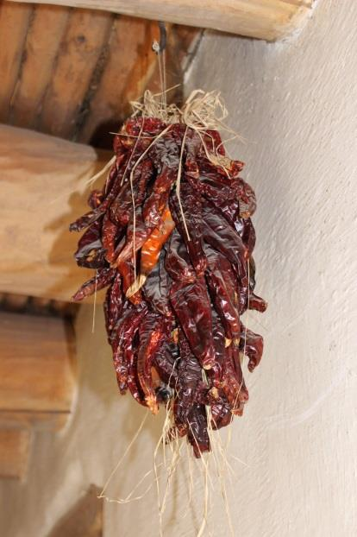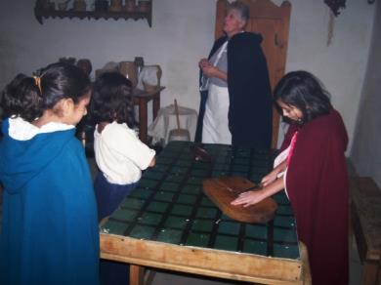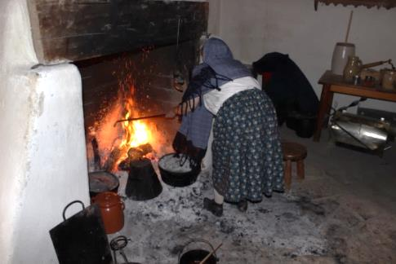(Room 6) William Bent’s Room
William Bent, one of the owners of Bent’s Fort, occupied this room with his wife (“Owl Woman” was her name.) What evidence do you find that the room is set up for the time when William Bent’s children were living here?

Dried Chilies

Woman cooking by the fireplace
Women preparing to cook in kitchen

Discuss
Why is no bed in this room? Answer: The owners were trading on the trail much of the time. William Bent’s Cheyenne wife, Owl Woman, would have preferred sleeping on the ground as was the custom of her tribe.

(Room 7) Fitzpatrick’s room
Fitzpatrick was an Indian Agent who negotiated with the Indians on behalf of the US government. Has anyone (including your parents) ever asked you to ask someone else a question… and then to tell them the answer?

Find clues in this room that reveal the following:
- Fitzpatrick worked with the Indians. (You may spot chairs used for sitting when visiting Indians.)
- Fitzpatrick knew how to read and write, unlike many other people of this time. Find the elk hide on the wall with pictures on it. This wall hanging depicts a Winter Count. Some Native Americans, such as the Lakota and Kiowa, would make a picture representing a big event that happened each year and paint it onto the elk hide. This Winter Count represents years leading up to 1847 when Charles Bent (White Hat) was shot and assassinated.
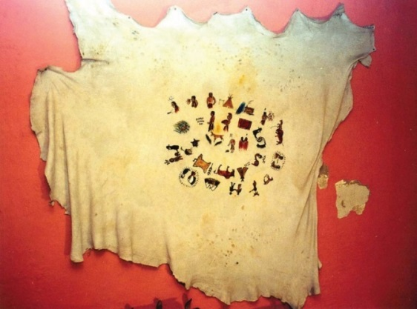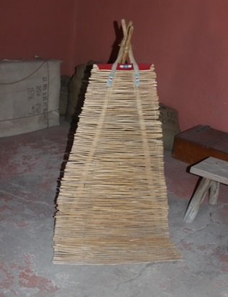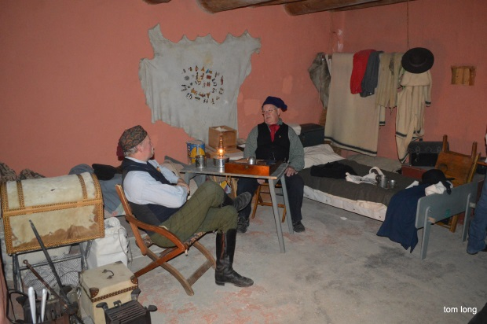

Elk Hide

Backrest, used by Plains Indians

Find the picture of a meteor shower on the elk hide.
- How do you know it represents a meteor shower?
- What year did it take place?
- Answer: Count backwards from the top left.
Many people of this time did not know about meteor showers. They saw what looked like stars falling from the heavens, and some people took this as a bad omen. Many stories were created about “The Night the Stars Fell.”

What is a meteor shower? (Multiple choice)
- Stars moving really fast in the sky
- Small bodies of matter (pieces of rock and metal) burning up in the Earth’s atmosphere
- Stars falling from the heavens and disappearing

Discuss:
- What tools do we now have to study meteor showers that the Native Americans in 1846 did not have? (Example answers: Telescopes, computers)
- If you did not know about meteor showers and you saw what looked like “stars falling,” what would you think it meant?
- Bonus: Star Trek calls outer space “The Final Frontier.” How does the mystery of outer space for us in the present compare to the mystery and appeal of wilderness space for the western pioneers in the 19th century?

(Room 8) Blacksmith’s Shop (Reminder: Do not go past the chain if it is up)
The blacksmith works on repairing wagon wheels, tools, and horse and oxen shoes, but may have other tasks as well. He does all his work in this room and sleeps in the room between his shop and the carpenter’s workroom.
“The ring of the blacksmith’s hammer and the noise from the wagoner’s shop were incessant.”- Lt. James Abert

Blacksmith’s Shop Activity:
Can you find 3 different tools? What do you think they were they used for?
Locate the forge (where the blacksmith heats the tools)
- What energy source does the blacksmith use to make tools? Answer: Coal
- Why is coal used instead of wood? Answer: Coal burns hotter. It is a necessary expense for the blacksmith’s work.

Can you find something that feeds the fire oxygen?
- Answer: The big black bag known as a “bellows” that hangs from the ceiling. This one is made from buffalo hides. Ask a park guide, if available, if you may pull the bellows, but do it respectfully. (Pull the metal rod with a handle that dangles near the fireplace as shown in the left picture).
- Can you feel the air coming out of the forge?

(Room 9) Craftsmen’s’ Quarters- (Blacksmith, Carpenter)

Discuss
- If this were your room, would you be satisfied with the amount of space?
If all your belongings had to fit in this room, what items would you have? What would you be willing to get rid of first?
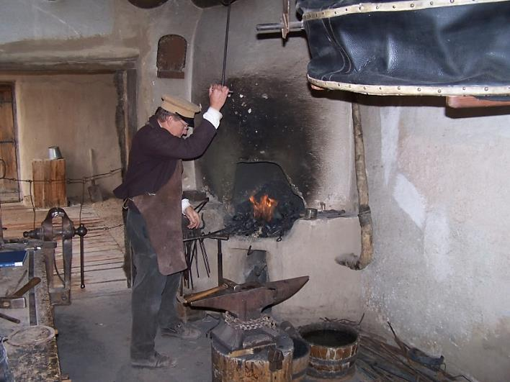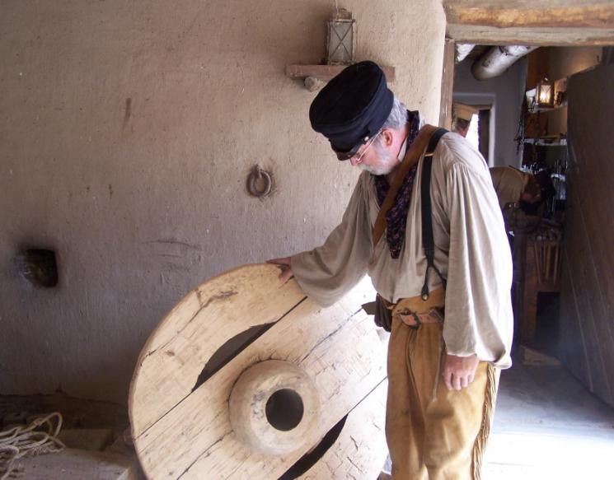

The carpenter and blacksmith worked closely together. While the blacksmith fixed the metal tires on wagons, the carpenter would fix the wheels.

(Room 10) Carpenter’s Shop

Discuss
- Find 3 different tools. What do you think they were they used for?
- When the carpenter wasn’t fixing wagon wheels, what else do you think he would be making?

(Room 11) Powder Room
This is where the fort stored gunpowder and cannon balls. Although the fort was never under attack, it needed to be prepared with a defense. The powder room is located right next to the bastion—the rounded areas at the corners of the fort that allow guards to fire in many directions from one spot.
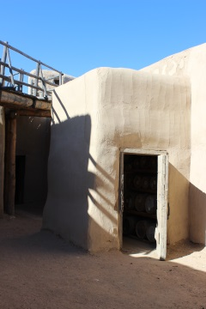
Powder room

Discuss
- What makes the location of the powder room a good one?
- What is the use of the powder? (Multiple choice)
A) Makeup B) Guns and cannons C) Sprinkling on wet floors to absorb excess water

(Rooms 12-14)- Storage Rooms
The first room stores supplies and trade goods. The military contracted with the Bents to store supplies here. The military warehouse has a raised underground storage area. The third room stores the fur that is later traded back east. 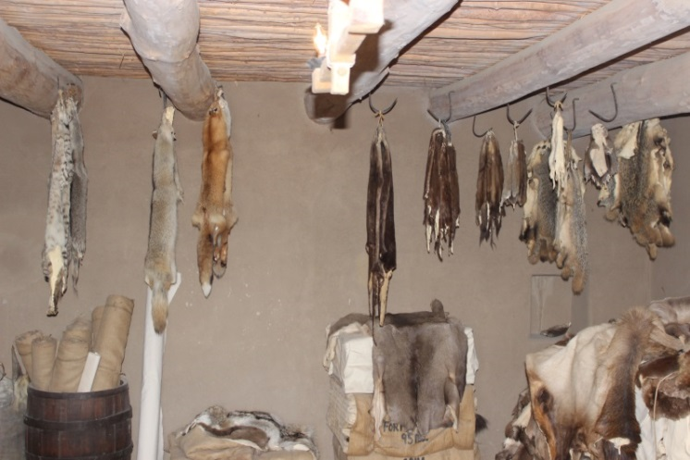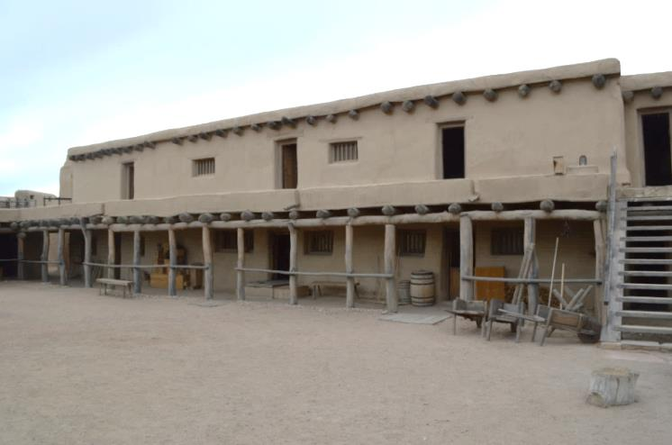Discuss:

Tom Long, West Side of Fort, Taken 02/29/2016

Furs may include coyote, fox, weasel, badger, otter, beaver, deer
- First room: What trade goods may have come from the east? From the south?
- Military Warehouse: What supplies might the military be storing here?
- Fur Warehouse: Can you identify any of the animal hides that are currently in this room?

(Room 15) Well Room
The water level fluctuates during the year, but it is still close enough to the surface to have a well. There are also journal entries saying that Bent’s Fort had an ice house and people of the fort had ice through August to use in their drinks, but there is no description of where the location of that room was. When someone fetched water, they had to climb the stairs down to the bottom and pump the well to obtain the water. Would you like to be a child during this time, fetching water for your mother when she needed it?

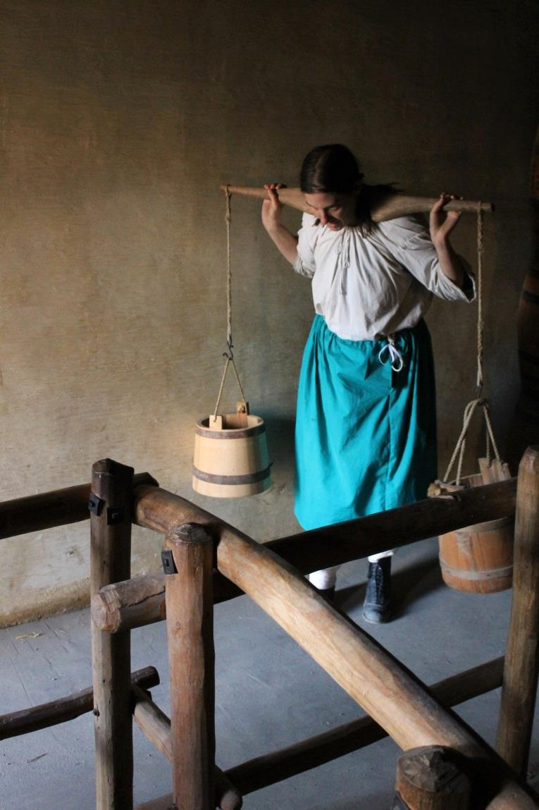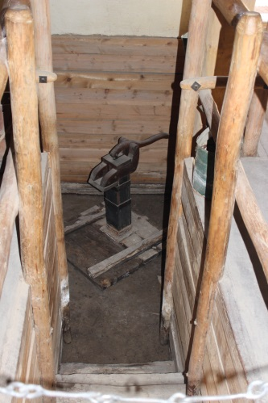

Discuss:
- What technology did the people of the fort use to get water? Answer: The well
- Is this a good location to have a well room? Is it good for women? For men? For Laborers? Why?
One answer: The cooks are busy in the kitchen; they would not like people going near where they are working. The women can also send their children to fetch the water. It is easier to get water from the well rather than going to the river for water.
Susan Magoffin wrote in her journal, “They have a well inside, and fine water it is – especially with ice.

(Rooms 16-19) Laborer’s Quarters
The fort has three rooms representing the laborer’s quarters. If one room is occupied by other visitors, you can use another one for this activity.
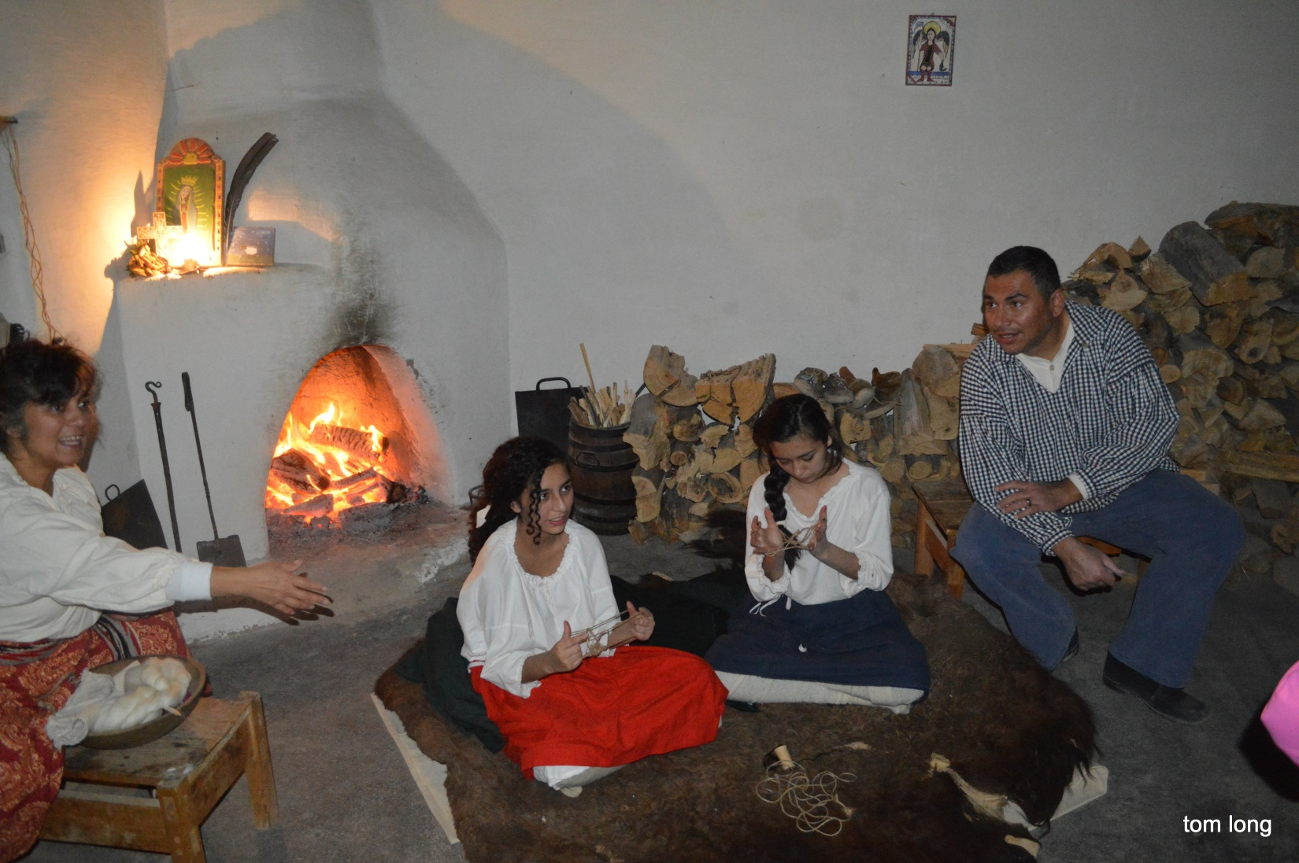

Laborer’s Quarters Activity:
Why did Mexicans come to this area? Answer: They came to work. They were hired for their extensive knowledge and experience of working with adobe and with the care and training of livestock. Moreover, Mexico was close… just on the other side of the river. Each room of the laborers’ quarters would have housed an entire family or more including a male laborer, his wife (who was also likely a laborer), and their children.

Discuss
- How many people are in your immediate family? (Mother, father, siblings)
- Would you want to live with your whole family in one of these rooms?
- Do you have more or less room in your living quarters with your family?
- Find retables (paintings on wood) in this room. What do you think the pictures would say about the people who lived here?

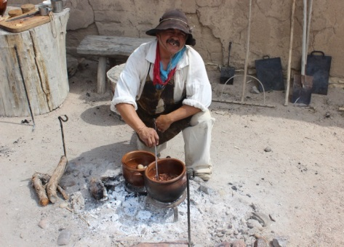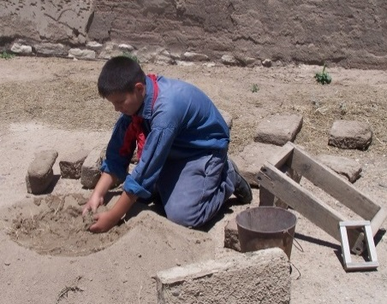

Find a picture in one of the laborer’s quarters. (There are 3 rooms with pictures to choose from.)
- What is the subject of the picture?
- What do you think is the artists’ interest?
- Do all members of your group agree with your idea of the picture’s meaning?
- Why would this artist want to make art about the world in which he lives?
- How does knowing about the art give us an understanding of the Mexican laborers of this era?
- There were not any places of worship at Bent’s Old Fort. People took their religion with them in different forms, such as paintings.
Estimate the area of the room (Or get an exact measurement if you have tools to use.)
- How tall are you? This is about the length of your arm span.
- Can you use your group to estimate the length of the room?
- Can you use your group to estimate the width of the room?
- Round your estimates to the nearest whole number.
- Can you estimate the area of the room? (Length X Width)

Look up at the ceiling. Supporting the ceiling, you see logs (Vigas) and smaller logs (Latias.) This is a characteristic of ceilings in adobe construction. Are the vigas and latias running parallel to each other or intersecting? 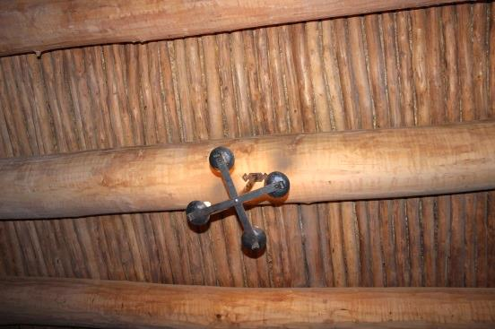
Vigas
Latias
Chandelier
Continue up the stairs to the Doctors Quarters

(Room 20) Doctors Quarters
Most forts had cabinets with medicines of the day. Trained doctors on the plains were of short supply, but many people had some knowledge of how to treat wounds and illnesses. At times, Bent’s Fort may have a physician among the workforce or travelers.
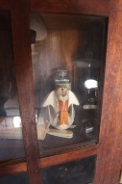
This is a beaver skull. This helps represent Doctor Hempstead’s hobby of being a naturalist.

Doctor’s Quarters Activity:
One of the temporary physicians of Bent’s Fort was Doctor Hempstead. Find clues to the hobbies of Doctor Hempstead, represented in this room. (Doctor Hempstead was a naturalist)
- Did Doctor Hempstead like to read? (He had a library, represented by a shelf of books).
- Find the medicine cabinet.
- What medicines do you see? (Leeches and bleeding were practices used to take out bad blood. Leeches are still used today in some medical situations.)
- Are there any medicines similar to medicines you have at home? (Probably not)
- Do you think 19th century doctors had different treatments to the treatments of the present?
- As for the animals of the fort, they would be tended by a veterinarian, or someone experienced in animal medicine.

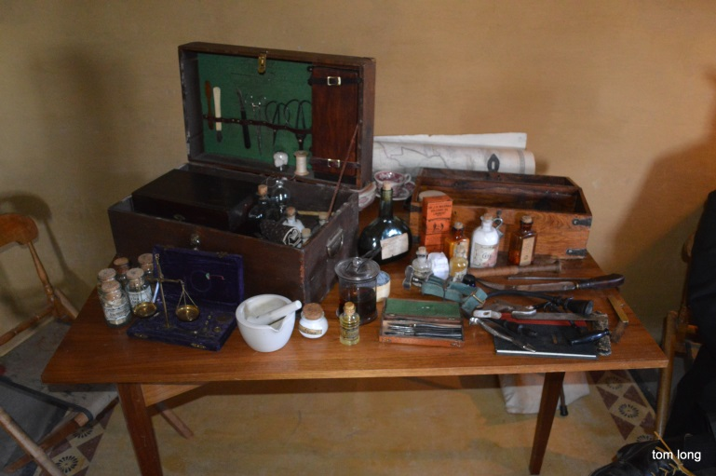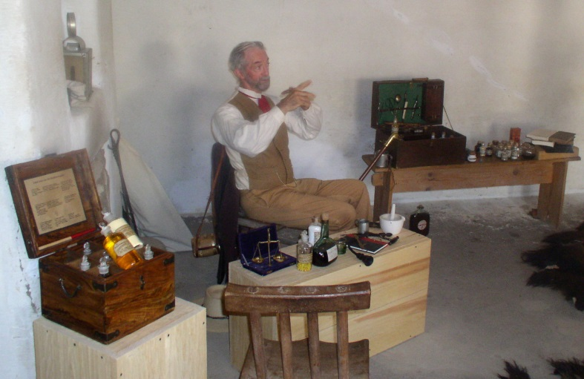

Susan Magoffin’s Quarters
Women were infrequent visitors/guests at Bent’s Fort. Most would have been Mexican or Native American wives of the men who worked at the fort, or their mixed children. The room adjacent to the doctor’s quarters represents the 12-day time span when Susan Magoffin was recovering at Bent’s Fort in August of 1846. Susan was a white woman from the east, and may have been the only one in the history of Bent’s Fort. She wrote a journal of her experiences down the Santa Fe Trail, that gives us an insight into her stay at Bent’s Fort. Do you keep a journal?
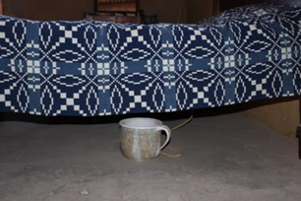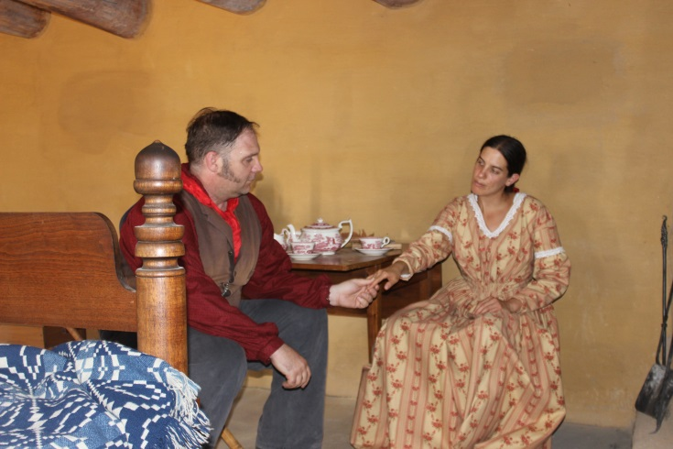

Chamber Pot
Susan and Samuel Magoffin

Discuss:
- Why would a woman from the east go to Bent’s Fort in 1846? Susan wanted to travel with her husband.
- Susan was ill. Why would she have been given this room to stay in? (One answer: Doctor is nearby.)
- What is under the bed, and what is it used for? Answer: Chamber pot – used as a toilet, especially at night.

(Rooms 21-22) Military Quarters (2 rooms) (Go right when leaving the Doctor’s Office)
Bent’s Fort was a Fur Trading Post, not a military fort. However, in 1846, General Kearny and his army of the west were marching south to Mexico. Some of his men fell ill along the way and were able to stay at Bent’s Fort to recover. Some men never did. These were the rooms the men stayed in. If you would like, you may sit on the floor for a minute and imagine what it would be like to be surrounded by sick men just lying down, staring at the ceiling. Men coughing, maybe moaning. The smell of body odor from men too weak to bathe themselves. Can you find clues that this represents where the military men were housed? (Answers include: Blankets and canteens say USA. Box says Army bread.) 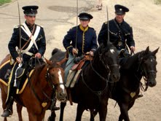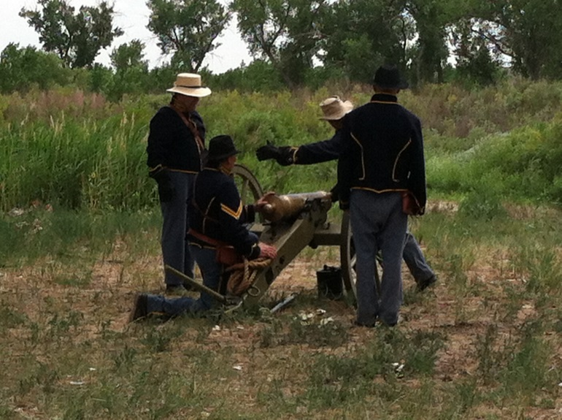

(Room 23) Trappers’ Quarters
Remember: You could touch anything in this room, but do not move it away from its location. Fact: Hatters would use Mercury to smooth the hairs of the beaver fur. Raise your hand if you heard of Mercury. It’s found in some thermometers. The fumes from the mercury would be inhaled by the person making the hat and give him neurological damage (brain damage) and that is where we get the saying Mad as a Hatter! Raise your hand if you would like that job.

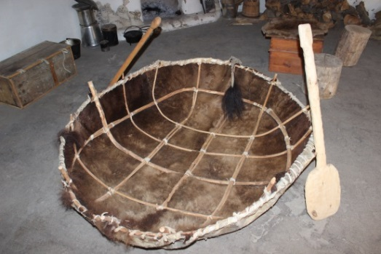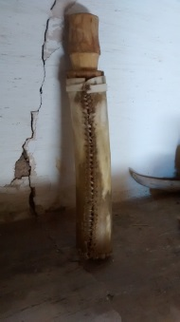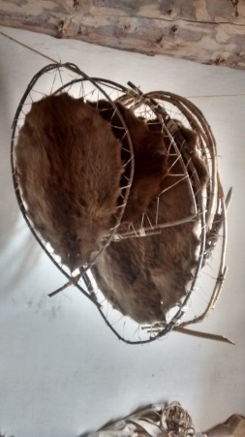Trappers’ Quarters Activity:

Bull Boat – made from a male buffalo hide

Castorium
Beaver pelts
Locate the Buffalo Boat (Usually on the right side of the room.)
- Does it look durable?
- Would it be able to last long trips or just short trips? Answer: short trips generally
- The river nearby is relatively shallow, why would this boat be needed in this location? Answer: it is for crossing the river.
Locate the fireplace. Near the fireplace, look for a bottle made of wood, it holds castorium. (Skip this section if you cannot find one.)
- Smell the bottle. (Optional)
- This wood has been scented with castorium.
- What is castorium made from? Answer: It is made from the gland of the beaver and used to attract beavers to a trap.
- Replace the cork on the bottle and put it back where you found it.
Locate a beaver pelt (round flat furry)
- What tools, you see in this room, would be used to trap a beaver?
- Bonus: Do you know the names of any trappers/hunters that worked here?
Answers include: Kit Carson, Uncle Dick Wooton, Jean Baptiste Charbonneau (Sacagawea’s son).

Room 24 Clerk’s Quarters. Look into the Clerk’s quarters.
Often the Bents and St. Vrain were absent from the fort. As a result, they appointed an overseer to make certain the fort operated as though the owners were present.

Discuss:
Using clues in the room, can you figure out the following?
- His job?
- His hobbies?

(25) Bastion
This Bastion provides the view of the corral and the land west and south of the fort.

Discuss:
Why might a worker be stationed here? One answer: Someone might look out for thieves who might steal livestock.
- How many livestock can you find from this view? (Livestock includes Horses, Oxen, donkeys, chickens).
- Are all the livestock you view in the coral? Sometimes the livestock are let out of the coral to graze in the surrounding. Look outside the coral and around the land.
Look at the corral. On the walls are, prickly pear cacti to protect against animals such as coyotes from climbing in , as well as Indians stealing horses. In addition, prickly pear cacti have another use.
- Bonus: Can you think of another use for the prickly pear cactus? One answer: they are edible.
Can you find the Arkansas River? If you are able to see the water, you probably see only a small section of the river. Can you find clues to help you know where the river is, even if you cannot see the water from here?
- Name five animals and/or plants that might live in or around the river.
- Why would it be a good idea to have a trading post this close to a river in 1846? (Water level, oxen grazing)
- Can you point East- the direction to trade in Missouri (Point left of the main entrance to the fort)
Can you point South- the direction to trade in Santa Fe (Point toward the river)
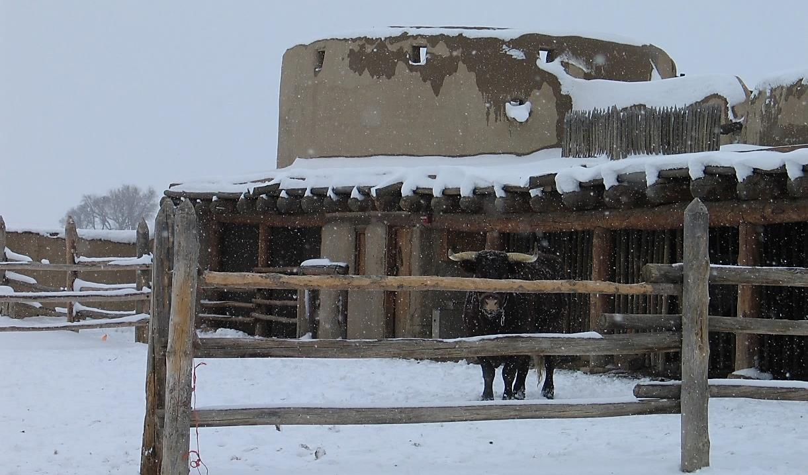

(Room 26) Billiard Room
This was the room where men got together at night to play games, gamble, tell stories and relax.

Billiard Room Activity:
Take a peak under the blanket. This is a billiard table. It is bigger than a pool table and the games played on it were different. It was shipped in two parts from back east and assembled here. Now put the blanket back over the table.
Look for a picture of a man sitting. Lieutenant Abert thought this man was a spectacular sight to see. He had the Indian sit on top of the billiard table to draw him!
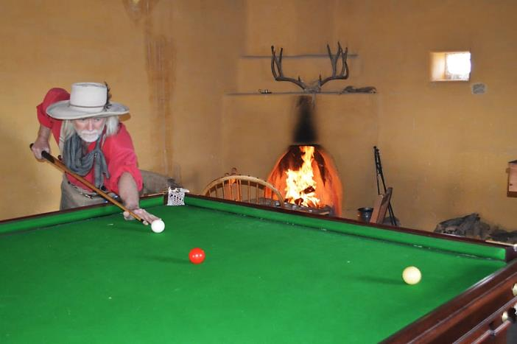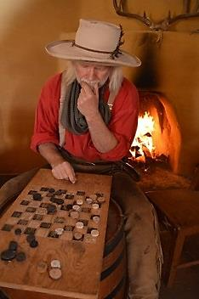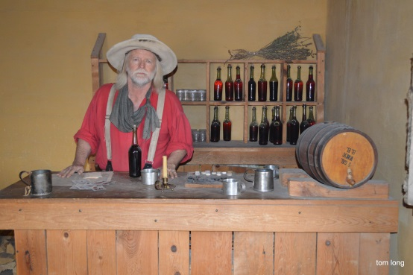Men would tell tall tales in this room. Some stories were true, some weren’t. Some stories were highly exaggerated! Challenge your group members to each come up with a short tall-tale (one minute long) of something they experienced. It does not have to be true. Keep it appropriate! The group could vote for their favorite story. Winner gets a high five from everyone in the group.

Tom Long, Billiard Room with Bob, Taken 02/29/2016

Susan Magoffin wrote in her journal, the servants “are gambling off their clothes till some of them are next to nudity.”

Find a deck of cards on the billiard table or back table.
- How do these cards compare to cards you use?
- Would you be able to play the card games you know with these cards?
- Not all cards had numbers on them. Why might the cards not have numbers on them? Answer: Not everyone knows how to read.

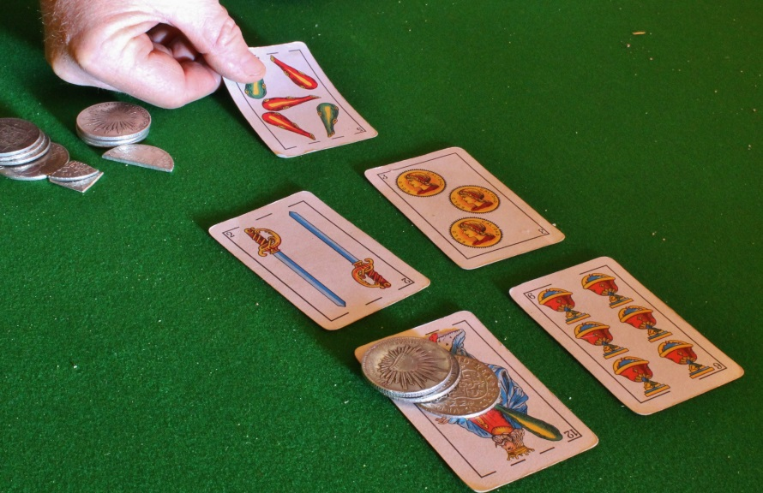 Robert Kisthart, Spanish deck of cards, coins and bits.

(Room 27) St Vrain’s Quarters
Ceran St Vrain is one of the owners of Bent’s Fort. It was not unheard of for all three owners to be out of the fort at the same time. The owners may be on the Santa Fe Trail with their wagons trading in Missouri or Santa Fe.
In 1846, Lieutenant Abert stayed at Bent’s Fort, in this room, to recover from an illness while St Vrain was not at the fort. Lieutenant Abert was a naturalist for the General Kearny’s Army of the West, which was marching towards Mexico.
Lieutenant Abert kept a journal and created paintings and diagrams. Look at his work, located on the table, right of the bed. Find a journal, a painting and a diagram. Why do you think his work may be important?
St. Vrain’s Room Activity:
Look at the journal. Find the page dated closest to the day and month you are here and read that page to your group.
- Is this journal a primary or secondary source of historic information? Do you know the difference?
(Primary could be from a person who witnessed an event, a secondary source uses primary or other secondary sources.)
- What was the journal entry about?
- How would this entry be different if Abert lived in the present?
- How are you similar to Lieutenant Abert? How are you different?
Find the painting of the plaza. This Fort you are in has been reconstructed. It had been destroyed and is now rebuilt. This painting, along with other diagrams, paintings and journals, helped in the reconstruction of Bent’s Old Fort.
- Bonus: Can you find any differences of the modern day fort and of Lieutenant Abert’s painting? (The modern fort has a safety wall around inner side of the second floor.)
- Why do you think these differences exist?

Find the notebook of paintings.
- What is the subject matter of these paintings?
- Can you tell what Lieutenant Abert was interested in? How do you know?
- Why did he spend time drawing, painting and collecting plants? (He was collecting information for the army).
- By viewing Abert’s artwork, what can you find out about him?

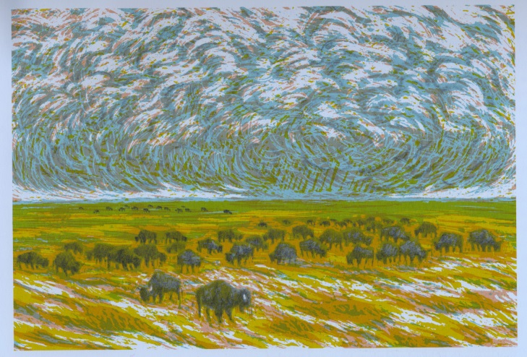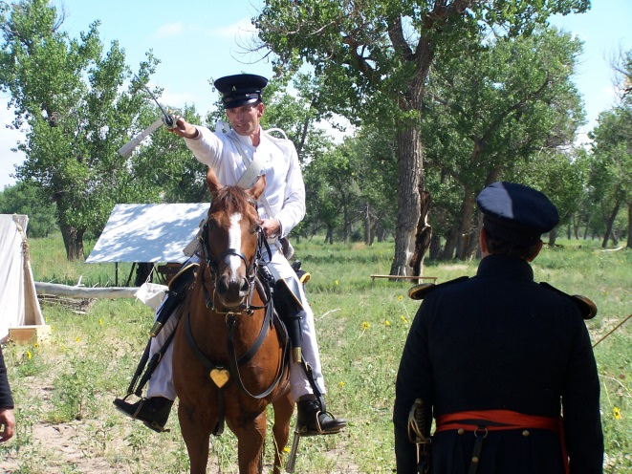

Buffalo painting by Lieutenant Abert

Bonus Question: If you were recovering from an illness at Bent’s Fort for three weeks similar to Lieutenant Abert, how would you pass the time? (There are no video games or electricity).

(Room 28) Guard Tower
Bent’s Old Fort was never attacked, but it was defended in case of attack. The bell could be rung to warn people if there was an attack, but it is rung to let Native Americans in the area know that the fort is being opened for trade. You may allow your class to each ring the bell once. A fort employee recorded in his journal that the guard tower once contained a fine telescope and on another occasion the tower held two captured bald eagles.
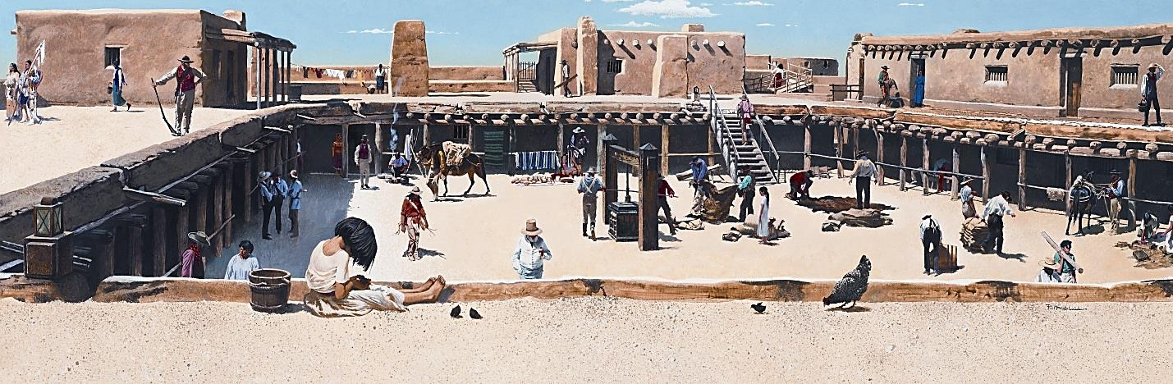
Painting of a View from the Guard Tower

Look at the Plaza
This is the central area of the fort. You may see many activities going on. There may be a laborer cooking a meal, kids playing games, mothers doing laundry and people working the fur press.
Take a minute to study the area. What do you hear? What do you smell? What do you see?
- Go down the stairs.
- Find stones in a line. This is an area where water drains from the plaza. It is called a French ditch.
- Go to the middle of the Plaza. Can you find a fur press? The Fur Press is used to pack furs, specifically Buffalo Robes, in order to pack as many as they could into wagons. At one point Bent’s Fort packed and shipped 30,000 pounds of Buffalo robes back east. Can you figure out how to operate this Fur Press? How does this technology help the people at the fort? (You may work the fur press).
- Can you find the laundry area? The laundry buckets would not be outside if it is too cold because the water would freeze. Doing laundry was much different than how many people do their laundry now. If there are rags nearby, have your group take a rag and figure out how to wash it. Then hang the rag up to dry.

Indian Trade Room
Notice between the two entrance doors there is a window.
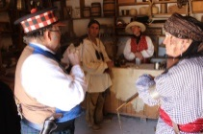
Discuss:
- Why do you think the window is there? Hint: The window faces in between the two sets of entrance doors. Answer: If there is a hostile Indian tribe, the inner doors could close and trade can take place through the window.

We hope you enjoyed your visit to Bent’s Old Fort National Historic Site.
If you are interested in visiting us again, we are open every day of the year except Thanksgiving, Christmas and New Year’s. Come back and have fun with us again!
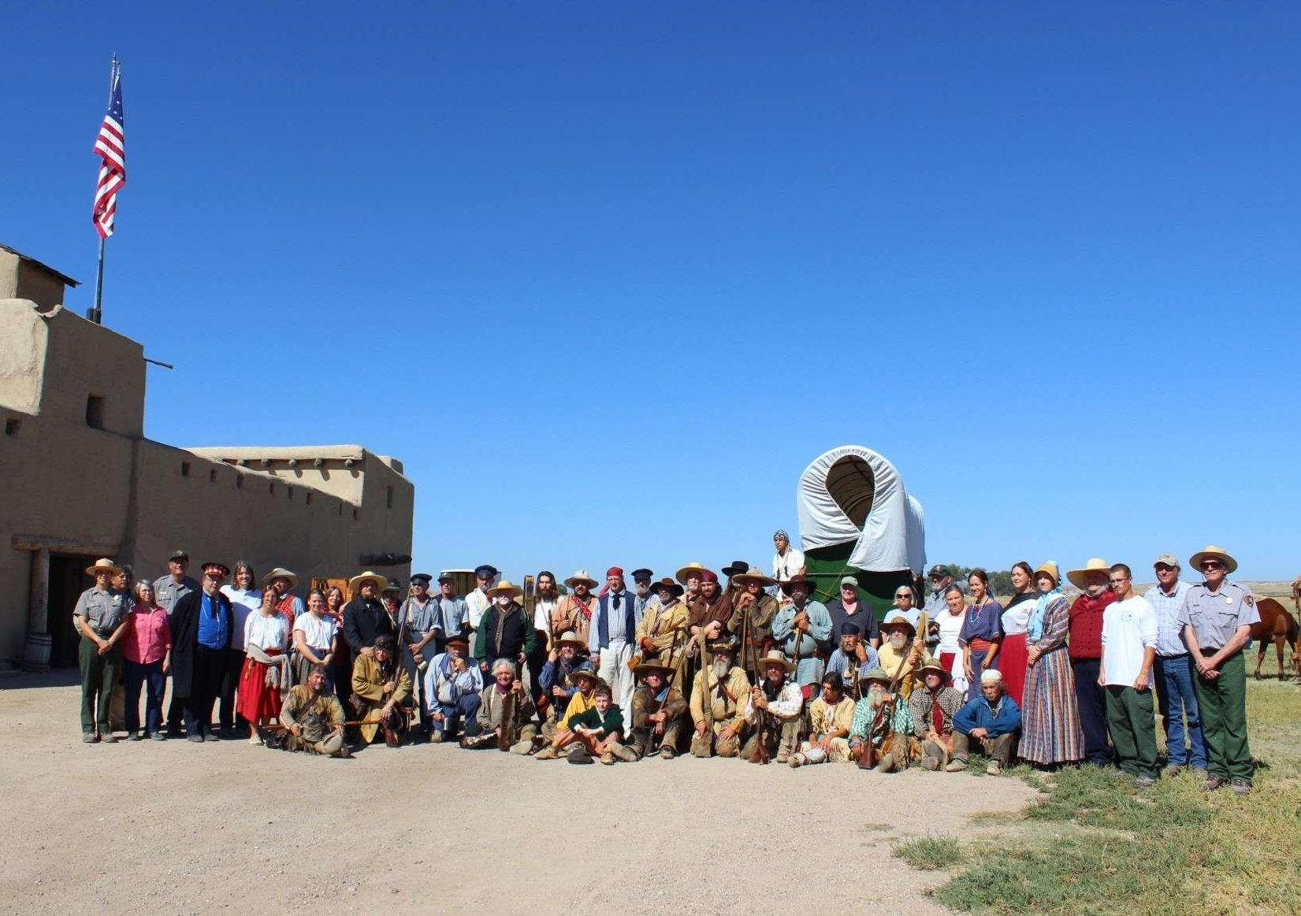

Additional Activities for when you go back home:
- This activity book was newly developed. Please share your feedback!
- Think about your experience here at Bent’s Old Fort National historic Site. Describe what happened. You could also pretend to write a journal entry from 1846. Include people, setting and events.
- Write a letter to us telling about your experience at Bent’s Old Fort National Historic Site. Include your name, what you liked, what you disliked, and what could we do to improve the experience for future visitors. Send your mail (with your parents or guardians permission) to
Bent’s Old Fort NHS
35110 Hwy 194 East
La Junta, CO 81050

